Preparation: Sources – overview
You have selected one of the thesis statements. Now it is time to identify and consult sources that you want to use during the assignment. Look up the sources carefully and make sure you are familiar with the content beforehand. Copy-paste the links to the sources in this document.
Please choose reliable sources, no *-pedia websites allowed.
Source (example) | Hyperlink
E.g.: Article: ChatGPT jack of all trades – master of none | https://www.sciencedirect.com/science/article/pii/S156625352300177X
Printscreen(s) of interesting information from the source may be inserted here – do not add text:

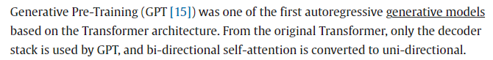

Source | Hyperlink
Article: Fact-Checking 8 Claims About Crypto’s Climate Impact | https://time.com/6193004/crypto-climate-impact-facts/
Printscreen(s) of interesting information from the source may be inserted here – do not add text: 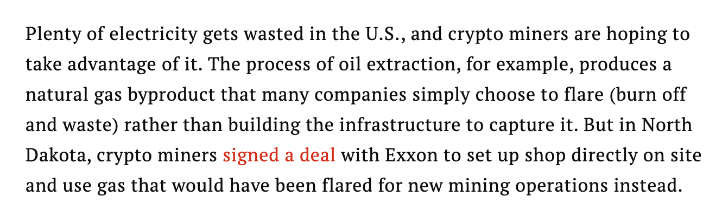

Source | Hyperlink
Article: Cryptocurrency return predictability: What is the role of the environment? | https://www.sciencedirect.com/science/article/abs/pii/S0040162523000355
Printscreen(s) of interesting information from the source may be inserted here – do not add text:
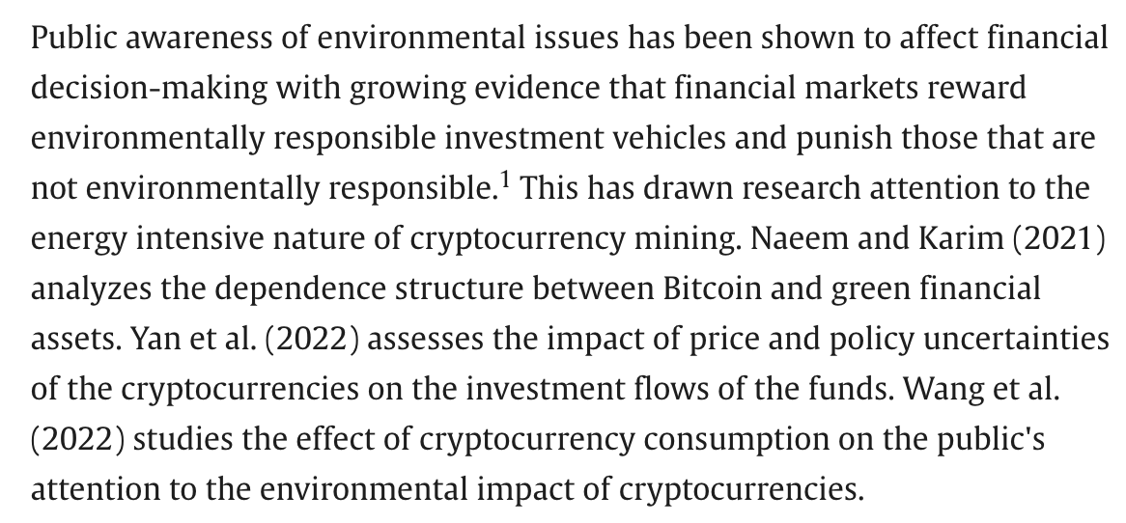

Source | Hyperlink
Article: Cryptocurrencies versus environmentally sustainable assets: Does a perfect hedge exist? | https://www.sciencedirect.com/science/article/pii/S1059056023000436
Printscreen(s) of interesting information from the source may be inserted here – do not add text:
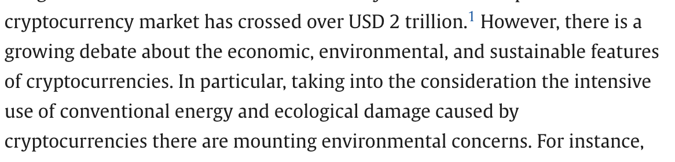

Source | Hyperlink
Article: Cryptocurrency Mining from an Economic and Environmental Perspective. Analysis of the Most and Least Sustainable Countries | https://www.mdpi.com/1996-1073/14/14/4254
Printscreen(s) of interesting information from the source may be inserted here – do not add text:
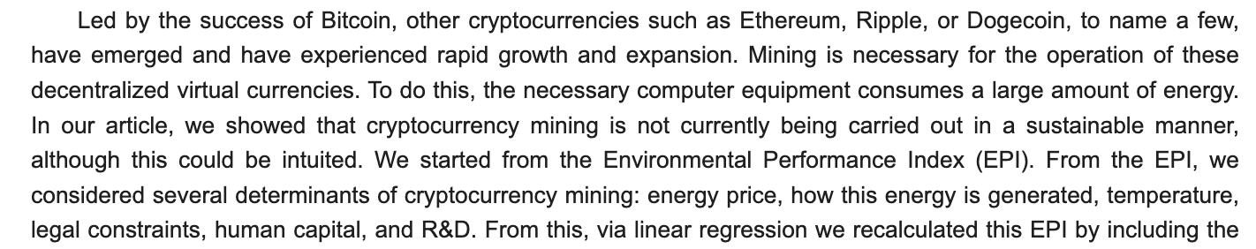

Source | Hyperlink
Printscreen(s) of interesting information from the source may be inserted here – do not add text:

Source | Hyperlink
Printscreen(s) of interesting information from the source may be inserted here – do not add text:

Source | Hyperlink
Printscreen(s) of interesting information from the source may be inserted here – do not add text:

Source | Hyperlink
Printscreen(s) of interesting information from the source may be inserted here – do not add text:

